

Human Biology ATAR Unit 2

Task 8 Validation – DNA Solutions

Weight 10%

1. a) Explain what is meant by gene expression. (2 marks)  
   Mechanism that produces a protein from a gene i.e. protein synthesis (1)   
   and turn genes on or off / expressing the gene or silencing the gene (1)

b) How does gene expression relate to a cell in a salivary gland? (2 marks)  
Salivary gland cell is **specialised** to produce amylase / digestive enzyme (1)  
so amylase gene is turned on and most other genes are turned off (1)

1. Explain how the epigenome allows the first section of DNA to be transcribed but not the second. (3 marks)

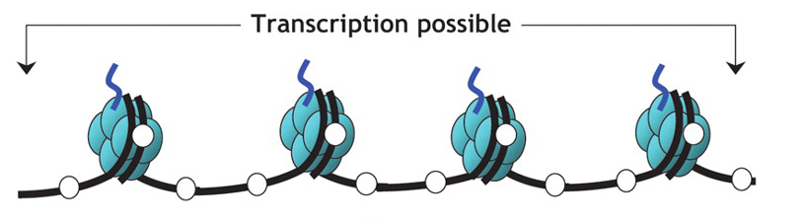

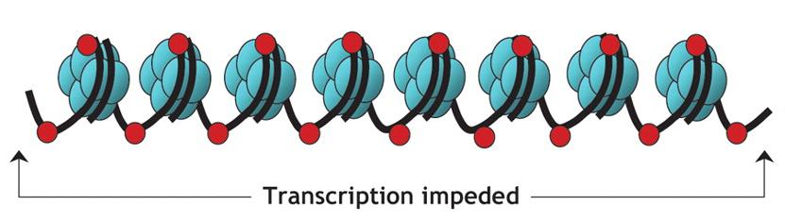  
In the first diagram DNA is less coiled / unwound / more exposed (1)

Due to no methyl markers / unmethylated cytosines / no DNA methylation (1)

Acetyl group added to histones / acetylated histones (1)

**NEED** Genes are expressed / swtiched on (1)

1. Seventeen-year-old identical twins, Adam and Michael, are both considered to be tall individuals: Adam is 192 cm and Michael is 188 cm. Explain how the different heights of Adam and Michael can be attributed to epigenetics. (3 marks)  
   Adam and Michael have exact same genotype / genes for height (1)  
   (At least one) environmental factor (diet/health) has differed between Adam and Michael during development (1)  
   More of Adam’s genes for height are expressed / turned on [or vice versa] (1)
2. This DNA profile shows a hypothetical example of how gene probes are used in forensic investigations. In this case a victim was murdered. There are three suspects under investigation. A blood sample was taken from the scene of the crime. The blood is believed to belong to the attacker. Two fluorescent probes were used to produce a DNA profile.
3. 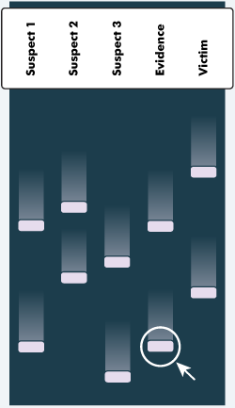Identify which of the three suspects was the likely killer. (1 mark) Suspect 1
4. What information from the profile helped you arrive at your answer? (1 mark) Same markers present as evidence
5. Why would a sample be taken from the victim and analysed? (1 mark) To show difference between victim and evidence
6. Until DNA profiling was developed, blood types and fingerprints were used as evidence to assist in the solving of crimes. Why is DNA profiling a more reliable technique? (2 marks) More points of difference (1) means greater accuracy / confidence (1)
7. What does the circled marker represent? (2 marks)

Small fragments of DNA (1) that have travelled further on the gel (1)

1. Discuss some of the ethical considerations surrounding genetic screening as it would relate to an embryo. (3 marks)

**NEED Able to predict genetic disorders (1)**

*Well articulated arguments:*

Decision to terminate pregancy vs long term care / quality of life (1)

Parents need education on consequences of choices (1)

Should screening results be made available to people other than parents? Insurers / doctors / church / state (1)

*Other valid arguments (1)*